**Introduction**

This is an over view of a media plan for Mukuru money transfers. The aim of this media plan is to come up with strategies and plans of how to use media in order to publicize Mukuru money transfers in Lesotho. Mukuru is the biggest leading way to send money in Africa and is a leading next generation financial service platform that offers affordable and reliable services. This media plan is devised to help the company promote its services in Lesotho and expand its usage in the country.

**EXECUTIVE SUMMARY**

This section of media planning provides a concise overview of the entire media plan, highlighting the essential information regarding the media objectives, strategies, tactics, target audience, budget and expected results. The key elements which should be included in the executive summary are brief overview, objectives, target audience, strategies, tactics, budget and evaluation.

The media plan has a brief introduction about the rationale of planning to promote Mukuru. The following section will be situation analysis on how Mukuru is currently promoting its services and what is lacking while doing so (the need for this media plan). This media plan aims to promote Mukuru to the targeted customers and maintain existing customers. The objectives of this media plan include raising awareness about Mukuru, eradicating unemployment by hiring service providing agents, making the process of transferring and receiving money through Mukuru simple for its customers, and making sure that people use Mukuru services in large numbers – attaining new clients. The media plan consists of variety of media channels and strategies which will be used to reach out to customers, including social media, radio and billboards. According to this media plan, Mukuru aims to target the people between the ages of eighteen and fifty. Then the budget for this media plan is estimated about… Lastly, evaluation…

**SITUATION ANALYSIS**

**Company Background**

Mukuru is a Fintech business which was established in 2004. Mukuru Website (2023) writes that Mukuru was founded in the United Kingdom as simple platform that allows a person in London to buy an international talk time voucher confirmed by text message to connect with family in Zimbabwe. The Mukuru platform is accessible on WhatsApp, free ussd, the Mukuru app and through the website and its services include cash transfers, Mukuru funeral cover, Mukuru card, Mukuru wallet and Mukuru groceries. The name Mukuru means elder in Shona and this name was established to show trust because and elder is a trusted person in Southern African communities.

**Competition analysis**

A competitive analysis is the process of examining a company and its competitors on the basis of size and share of market, sales history including costs and profits, the use of advertising and the nature and the types of customers and more (Jansoo, 2019).Mukuru is the easiest and most reliable money transfer service living up to its motto of being more than just money transfers. It offers cutting edge of technology driven financial products and services around Africa since its existence in 2004. Moreover, it continues its quiet revolution across the African continent to deliver world class service to people who have never had access to mainstream financial services.

Additionally, currently Mukuru has more than 800 Mukuru orange booths getting on with business of spreading the financial freedom and inclusively the African continent by enabling families of migrant workers to receive cash when and where they need it most (Anderson, 2023). Moreover, Mukuru recently partnered with a number of United Nations agencies and humanitarian organisations like Finmark trust and action Contre la Fim to work with Mukuru using their reach and capabilities to deliver and guarantee on time payments for some of the world's most vulnerable recipients of humanitarian aid. Not only that but in June 2019, the company brought Asia on board to ensure efficiency in the new market that demands a richer front- end experience and more sophisticated technological solutions. For instance, Mukuru entrenched its presence in India, Pakistan and Bangladesh (Jansoo, 2019).

In addition, in 2020 Mukuru expanded into China because of the Covid 19 pandemic that forced people to stay indoors for some time. There were several hundred booths of Mukuru which enabled more than 100 brands to provide cash out points in China and Mukuru launched WhatsApp direct sign ups and demand for electronic products all over China (Anderson, 2023).

Shoprite money market is Mukuru biggest competition in Lesotho. As asserted by Anderson (2023) competitors are businesses who can offer the similar goods and services to one's customers. Shoprite money market is Mukuru's competition right now because it is also a platform where Basotho are able to receive money from their loved ones from South Africa even if they do not have a bank account. However, even though Mukuru helps people in Lesotho to receive money from the their loved ones in South Africa', its weakness is that, Lesotho citizens cannot yet sent money outside of Lesotho to their loved ones in the neighboring country.

**Target Audience Analysis**

Lesotho as a country has almost half of it population as immigrants in other countries. According to Botea, Chakravarty and Compernolle (2018), the 1996 census revealed that the registered population of 1 960 069 for the 2001 demographic survey of Lesotho. In 2014, almost 43% of household reported one member living away in South Africa, (Botea, Chakravarty and Compernolle, 2018). Training centre (2014) assets that most migrants are between the age of 20-59, and majority of them are between 30-49 years for both genders. Most immigrants from Lesotho who are in other countries are from rural areas and many of them ended their education at primary level due to lack of resources, (Botea, Chakravarty and Compernolle, 2018).

This means that the target market for Mukuru are low to medium income earners with mostly a low level of education and so all messages will be designed in a way that is suitable for them. Again, because 43% of households have reported at least one member living away in another country, it is important to design messages that will suit both target markets in the low lands and in the high lands.

**Company Objectives**

Objectives are clear guidelines that have to be followed in order for an organisation to achieve its goals. Objectives have a time frame and it is normally a year or less, (Birt 2022). Objectives describe the actions for activities involved in achieving a goal.

The first objective is to raise awareness about Mukuru. The target audience is people who are working outside the country and people who have loved ones working outside the country. The media plan’s objective is to inform people and make them aware of the service of Mukuru and to persuade them to use the service because it is good for them. Using Social media (Facebook) to promote the service will help to spread the message to mass audience because people use it a lot lately and it reaches a larger audience.

The second is to create jobs. As a way of making people aware of Mukuru there will be people hired for registrations. They will be called service providers, as they will canvass and tell people about Mukuru, as well as going door to door and helping people with Mukuru registrations. This will help create jobs and people will paid by commission.

The third is to simplify the money transfers. People are always worried when they have to send money to people in different countries because of the complications entailed in the transactions they have to make. The complications include providing identification documents every time people send money and with Mukuru the money is from the sender and directly into the recipient’s account because it is a mobile banking application.

The last objective is to make sure that more people use the service. Mukuru is an existing service however there are still long queues at the money markets of people waiting to make a withdrawal of their money. This observation shows that not many people use Mukuru and its because they are not aware of it or they just do not understand how it works. Making them aware of the service, explaining how it works and registering people will make more people use it.

**Target Audience Objectives**

A target audience is a group of people defined by a certain behaviour (Neto, 2016). Identifying target audience allows the business to focus their marketing efforts and dollars on the groups that are mostly likely to purchase the businesses products or services (Neto, 2016). In addition, Dahikar (2017) relate that the target audience share demographic similarities such as age, sex or socio economic status amongst others. The target audience of Mukuru are individuals of ages 18 and 50 years. These are the people who at least have one person who is working outside of the country and needs to receive money to their loved ones.

Furthermore, Curtis (2018) asserts that identifying target audience helps the company craft a messaging strategy that appeals directly to the type of consumers who are more likely to convert into paying customers. This means that Mukuru will tailor messages that appeal to the target audience needs effectively in order to solve their everyday problems. Also, these messages as are meant give customers solutions to their everyday international money transfer problems.

**Geographic Objectives**

Geographic segmentation refers to putting people into different groups or categories based on where they live (Martin, 2016). Furthermore, Goyat (2017) says geographic segmentation also organizes audience into groups based on their physical location such as urban, suburban, and rural areas, not only that but geographic segmentation also allows companies to target varying wants and needs of customers in different regions (Nguyen, 2016). Mukuru is targeting both the urban and rural people therefore the messages tailored for people in the urban areas will differ from that of people in the rural areas because they have different settings and understand things differently.

Additionally, Madeira (2016) affirms that geographical segmentation allows businesses to create more targeted and customised marketing campaigns that are better suited to the needs and preferences of different customers in different geographical regions. Mukuru will therefore use different media channels to deliver messages to the businesses varied audience as they prefer different media channels. For instance, people in the rural areas prefer MoAfrika FM because it is mostly accessible in the rural areas while the people in the urban areas mostly use social media platforms and are exposed to billboards frequently, therefore all the audiences needs will be catered for.

**Scheduling/ Timing objectives**

**Pulsing**

**Reach and Frequency objectives**

Reach or market reach is defined by Spencer (2020) as the estimated number of potential customers exposed to an advertisement. While frequency is the number of times target audiences view an advert during a specific time, (Spencer, 2020). The desired reach for this campaign is 60% of the 43% of Basotho house holds with at least one member living in another country. Microtrends (2023) states that as of 2022 United Nations put Lesotho’s population at 2, 305 825 million. 991 504 thousand is equal to the 43% of the country who are migrants. 60% of this number is 594 902.4 which is equals to the desired number of target audiences reached.

**Calculations**

**Number of households with migrant=** percentage/population

=43/100(2, 305 855)

=991 504.8

**Total number of audience**= desired media reach*total number of migrants*100%

= 60/100(991 504.8)

= 594 982.4

The aim is to reach at least 45% using MoAfrika FM, 25% using Facebook, 15% using billboards and the remaining 15% using Lesotho Times.

**Reach and Frequency graph**

This is the graph for the desired frequency and reach for Mukuru media plan.

**Reach and Table for Twelve Months**

**First Half of the year**

|  |  |  |  |  |  |  |  |  |  |  |  |  |  |  |
| --- | --- | --- | --- | --- | --- | --- | --- | --- | --- | --- | --- | --- | --- | --- |
| **Medium** | **Number of times an advert played over six months** | | | | | | | | | | | | | |
| **January** | | **February** | | **March** | | **April** | | **May** | | **June** | | **Total** | |
| **Weekly** | **Monthly** | **Weekly** | **Monthly** | **Weekly** | **Monthly** | **Weekly** | **Monthly** | **Weekly** | **Monthly** | **Weekly** | **Monthly** | |  |
| **MoAfrika FM** | **4** | **16** | **2** | **8** | **2** | **8** | **4** | **16** | **2** | **8** | **4** | **16** | | **72** |
| **Ponahaletso Billboard** | **7** | **31** | **7** | **28** | **7** | **31** | **7** | **30** | **7** | **31** | **7** | **30** | | **181** |
| **Lesotho Times** | **1** | **4** |  |  |  |  | **1** | **4** |  |  | **1** | **4** | | **12** |
| **Facebook** | **4** | **16** | **4** | **16** | **4** | **16** | **4** | **16** | **4** | **16** | **4** | **16** | | **64** |
| **Grand total** |  |  |  |  |  |  |  |  |  |  |  |  | | **329** |

The above shows the number of times Mukuru adverts were displayed across different media platforms over the first six months of the year.

**Second Half of the year**

|  |  |  |  |  |  |  |  |  |  |  |  |  |  |  |
| --- | --- | --- | --- | --- | --- | --- | --- | --- | --- | --- | --- | --- | --- | --- |
| **Medium** | **Number of times an advert played over six months** | | | | | | | | | | | | | |
| **July** | | **August** | | **September** | | **October** | | **November** | | **December** | | **Total** | |
| **Weekly** | **Monthly** | **Weekly** | **Monthly** | **Weekly** | **Monthly** | **Weekly** | **Monthly** | **Weekly** | **Monthly** | **Weekly** | **Monthly** | |  |
| **MoAfrika FM** | **4** | **16** | **2** | **8** | **2** | **8** | **4** | **16** | **2** | **8** | **4** | **16** | | **72** |
| **Ponahaletso Billboard** | **7** | **31** | **7** | **28** | **7** | **31** | **7** | **30** | **7** | **31** | **7** | **30** | | **181** |
| **Lesotho Times** | **1** | **4** |  |  |  |  | **1** | **4** |  |  | **1** | **4** | | **12** |
| **Facebook** | **4** | **16** | **4** | **16** | **4** | **16** | **4** | **16** | **4** | **16** | **4** | **16** | | **64** |
| **Grand total** |  |  |  |  |  |  |  |  |  |  |  |  | | **329** |

This table shows the number of times Mukuru adverts were displayed across different media platforms over the first six months of the year.

**Media Objectives**

**Facebook**

**Radio**

**Billboard**

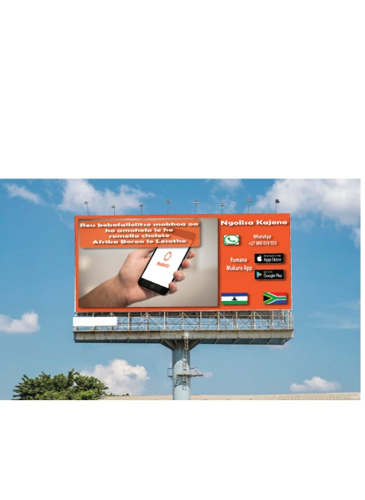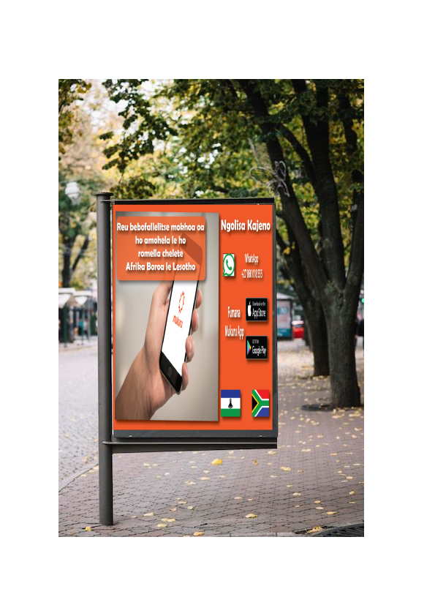

**Newspaper**

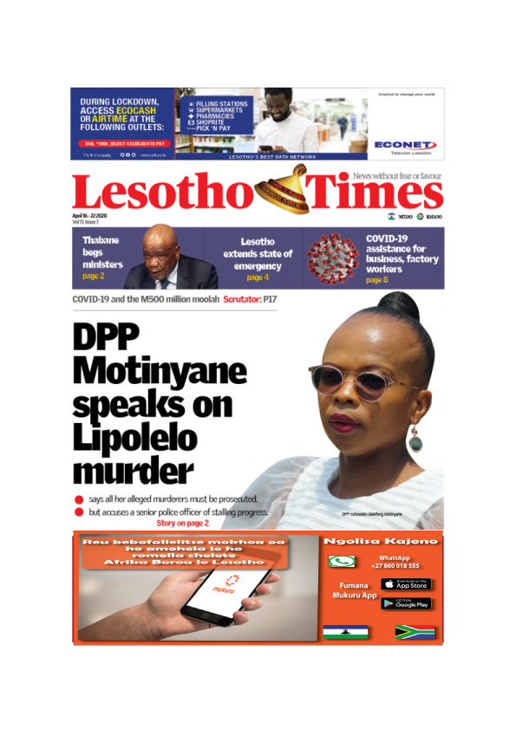

**MEDIA STRATEGY:** this section outlines the overall strategy to be used to reach the target audience, including the types of media that will be used to reach target audience.

To promote Mukuru, the following media strategies will be used: **social media advertising (Facebook), billboards radio and newspaper.** The reasons for choosing these media platforms are that, firstly, social media advertising is very cheap, especially Facebook. Advertising on Facebook is free and the adverts can reach a lot of people very fast and effectively since many people with access to social media are on Facebook. This also includes the target market of Mukuru which are the people between the ages of 18 and 50. Furthermore, to increase the reach with advertising on Facebook comes with affordable prices. For example, for an advert to reach double the number of people the initial advert had managed to reach, the price for post boost per advert is only 250 Maloti. Facebook advertising will help Mukuru grow because many users will be aware of the services Mukuru provides when scrolling in their newsfeed, especially the working youth and young adults who are constantly logging in every day.

Secondly, radio is another good medium to use for promoting Mukuru and the services it offers. This is because radio is widely used in Lesotho. So, using radio can definitely be useful considering that radio adverts are also not very expensive. The right station (s) also need to be taken into consideration when advertising Mukuru on radio. Because in order to advertise effectively and reach the goal of advertising, the most listened and preferred station (s) nationwide in Lesotho will be the ones used for promoting Mukuru. In this case, it will be easier for target market to consider Mukuru services when needing the company that can help them to send and receive money easily and safely. Hooper (2017) corroborates this by saying that once an advertiser has a good comprehension of the kind of people he or she wants to target, he or she will be able to pinpoint the perfect station. This will help the advertiser reach a greater number of interested consumers.

Lastly, billboards can also help to promote Mukuru services. Billboards will help Mukuru to grow because they are usually placed in towns when large numbers of people see them, and alongside the roads where people pass every day. Also, billboards tend to be relatively affordable depending on the size of the billboard and the location. Hence this makes billboards a perfect platform to promote Mukuru with, for its advertisements every day exposure to the large audience. Again, billboards are beneficial for advertising Mukuru, because they will help the company to minimize the advertising budget. They are a pay once for more. This is because billboards reach a large variety of customers with a single advertising approach, as already mentioned above. Thus, instead of Mukuru spending extra time and money to identify and research niche target customer groups, a single billboard advert can allow it to reach a large part of the diverse general population in a certain area.

**REFERENCES**

Birt, J. (2022). *Goals vs.* Objectives: *What’s the Difference?.* Available at: <https://www.indeed.com>.

Anderson, A. (2023). *Situation Analysis and Strategic Planning*. [Online]. *Innovative Marketing* 2(2). 134-141. Available at: <http://www.researchgate.net>. [Accessed 12 April 2023.11:00 p.m CAT].

Jansoo, T. (2019). *Methodology for Situation Analysis*. [Online]. *Journal of Resources and Management*, 24(21). Available at: <http://www.sciencedirect.com>. [Accessed date 12 April 2023 10:00 p.m CAT].

Hooper, S. (2017). *Why Would You Use Radio Advertising?* [Online]. Available at: <https://www.infront.com>. [Accessed date: 10 April 2023, 14: 30 pm CAT].

Curtis, A. (2018). Master's Programme for Strategic Entrepreneurship for International Growth. School of Business and Engineering: Sweden.

Dahikar, T. (2017). Defining Target Audience. [Online]. Available at: <https://www.researchgate.net//>. [Accessed date 3 May 2023. 10:30 a.m. CAT].

Goyat, H. (2017). Marketing Segmentation. [Online]. Available at: <https://www.researchgate.net//>. [Accessed date 4 May 2023. 9:00 a.m CAT].

Madeira, M. (2016). Building A Geographic Segmentation Model. [Online]. Available at: <https://www.google.scholar.com//>. [Accessed date 4 May 2023. 11:00 a.m CAT].

Martin, S. (2016). The Basic of Market Segmentation. [Online]. European Journal of Business Management, 9(3). 110-115. Available at: <https://www.google.scholar.com//>. [Accessed date 5 May 2023. 10:00 a.m CAT].

Neto, J. (2016). The Importance of Marketing Segmentation. [Online]. American Journal of Business Education, 4(6). 98-103. Available at: <https://www.google.scholar.com//>. [Accessed date 4 May 2023. 7:30 a.m CAT].

Nguyen, P. (2016). Target Audience Identification and Data Collection Methods. Utah State University: USA.

Training Center. (2014). Migration in Lesotho. [Online] Available at: <Https://www.trainingcenter.unwomen.org>. [Accessed date 18 May 2023, 08:27 CAT].

Botea. L., Chakravarty, S., & Compernolle, N. (2018). Female migration in Lesotho. [Online] Available at: <https://openknowledge.worldbank.org/entities/publications/ab1202ecff2b-5c72-4a3642421d58>. [Accessed date 18 April 2023, 12:30 CAT].

Spencer, G. (2020). What are reach & frequency and how they work? [Online] Available at: <https://www.kctv5marketing.com>. [Accessed date 10 May 2023, 06:54 CAT].

Micro Trends. (2023). Lesotho population growth. [Online] Available at: <https://www.microtrens.net/countries/LSO/lesotho/popilation-growth-rate>. [Accessed at date 10 May 2023, 08:41 CAT].